To Hell and Back- if it's possible!
An article in October 2010 Everyday & Practical Electronics reminded me of one of my favourite electronic circuit mysteries- namely, why do circuits sometimes work when they should not, according to normal expectations? Here's the circuit. That digital inverters can work as ac amplifiers is true but unpredictable in quality. But that detector section, D1/C3??
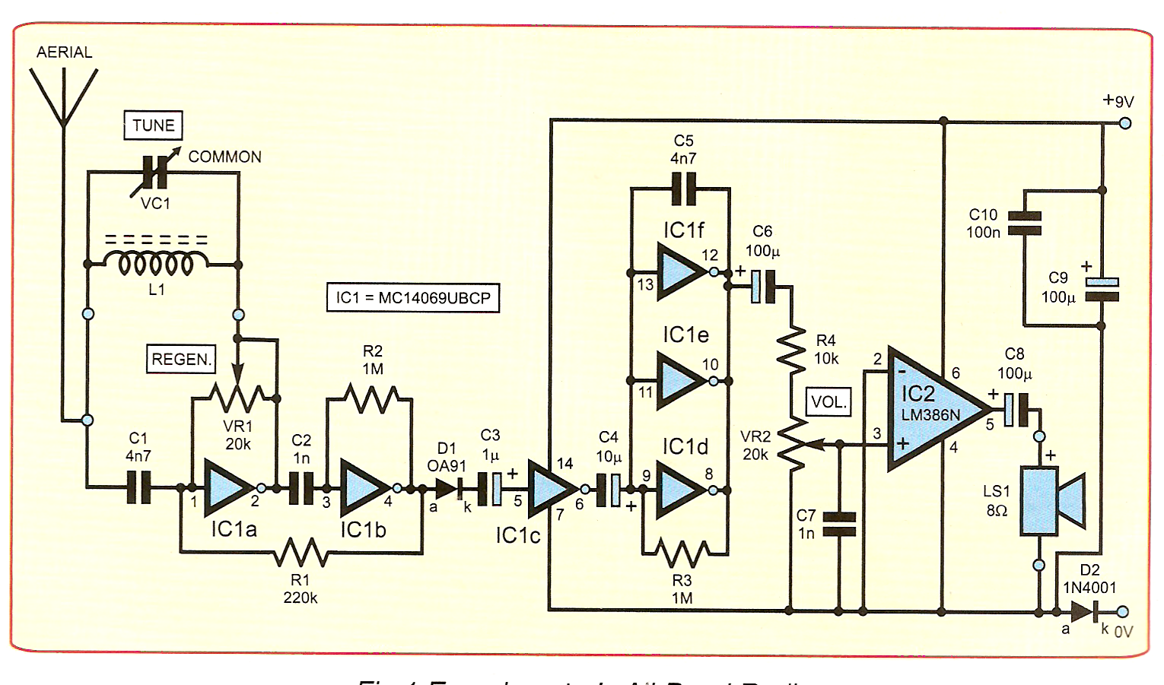
I call it a favourite, because twenty years or more ago I made a point of collecting variations on this particular fallacy. And I find it is still current- my favourite example is from Cambridge University.
Remember the 'hydraulic analogy'? It often helps to think of electricity in circuits of wires as being like water in circuits of pipes. Pumps try to create flows, and can be one directional ( dc) or reciprocating ( ac). Sections of pipe may have higher resistance than others to flow. Pressure gauges are like voltmeters, measuring pressure differences between places. Flow-meters- perhaps a little propeller in a pipe- show flow of current. And it all gives you an ability to visualise what is going on.
What is less often realised is you can add analogues of capacitors, diodes and inductors.
Consider two devices.
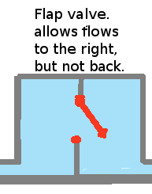
- a diode. It 'lets electricity through in one direction and not the other.'
Its use therefore is nearly always to remove one direction of an alternating current, leaving uni-directional pulses with gaps between them.

In Physics lessons we used a hydraulic analogy- a pipe with a flap valve letting water through only one way.
- a capacitor. It 'lets fast enough a.c. pass, because it does not have time to build up a significant opposite voltage before the input reverses sign.'
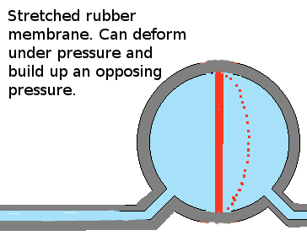
Its main use therefore is either to pass frequencies high enough for its reactive impedance 1/( 2 pi f C) to be low, or to smooth out voltage variations.

The hydraulic equivalent here is a rubber sheet right across the inside of the pipe. Push or pull, and surges of charge flow in or out depending on how hard you push.

No problems there. Both analogues make sense and help clarify your ideas. OK, there are minor serial & parallel resistance issues, and diodes have a characteristic ( V/I curve) which is exponential, but often approximated to a finite 'forward turn on' of about 0.7V for silicon. They also have a voltage sensitive 'junction capacitance, but this is seldom above a few tens of pF.
And mechanical breakdown of the analogues at high pressures is exactly what happens to the electrical equivalents.
So what happens with them in series?
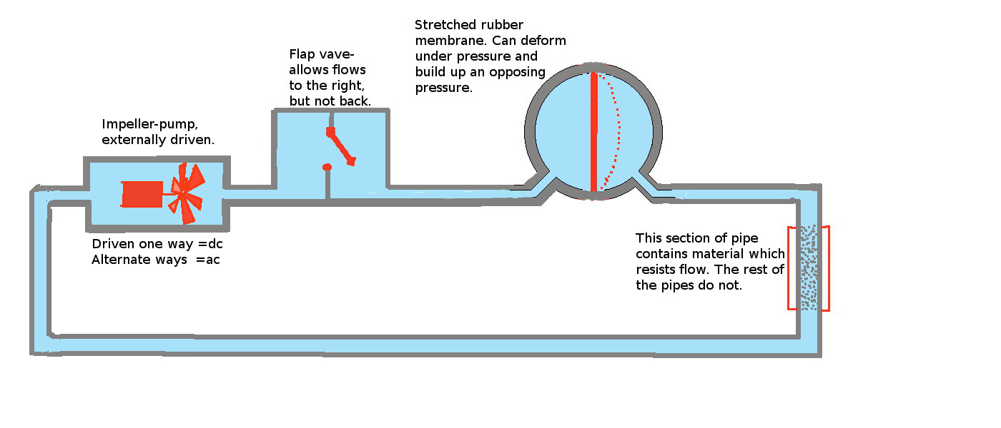
Well, as the actress said to the Bishop, or possibly the diode to the capacitor,
'You can't have it both ways!'.
Put a diode in series with a capacitor, and, long term, no ac nor dc can pass. At first, positive current pulses will get through ( loosely, if over the 0.7V 'threshold'.) but as this builds up an extra opposing voltage on the capacitor plate they experience bigger and bigger thresholds, and pass less and less charge, until NO current flows. And that means no pressure-difference across the resistor- no output 'voltage'.
In the hydraulic analogy, the flap valve lets successively smaller surges of water deform the rubber membrane until it is no longer possible to exceed the pressure and open the flap at all. The pump ratchets up a little at a time until stranded at a position where it can't push hard enough to open the flap because there is the back-pressure from the rubber membrane, and can't go back because the flap valve never allows flow in that direction.
So why can I find so many examples like this in print and on the net, all implying it operates as an amplitude detector?
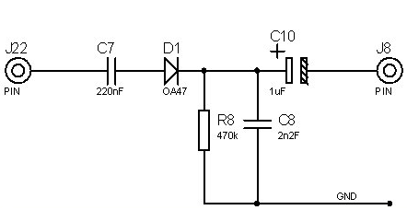
The series diode/capacitor C7/D1 should not pass any ac or dc after a charging interval!
In the past, to simulate this I had to write programs and graphic displays or use a spreadsheet. But EE has kindly publicised the free circuit simulator LTSpice, and put a trial version of TINA on a recent 'special issue' cover, and Qucs and others are free under Linux. So I thought it would be good to learn to use them to model this situation.....
With LTSpice I simulated a suddenly-starting ac sine wave of 100 kHz and amplitude 1V rms, applied in series with a 10 nF capacitor and a 1N914 diode and 100 kohm resistor. This gives a 1ms dc time constant, so on diminishing positive pulses it will drop output to zero well before 1s is up. ( Instead of getting the steadily decreasing input it gets shorter and smaller pulses) Which is exactly what the traces show.

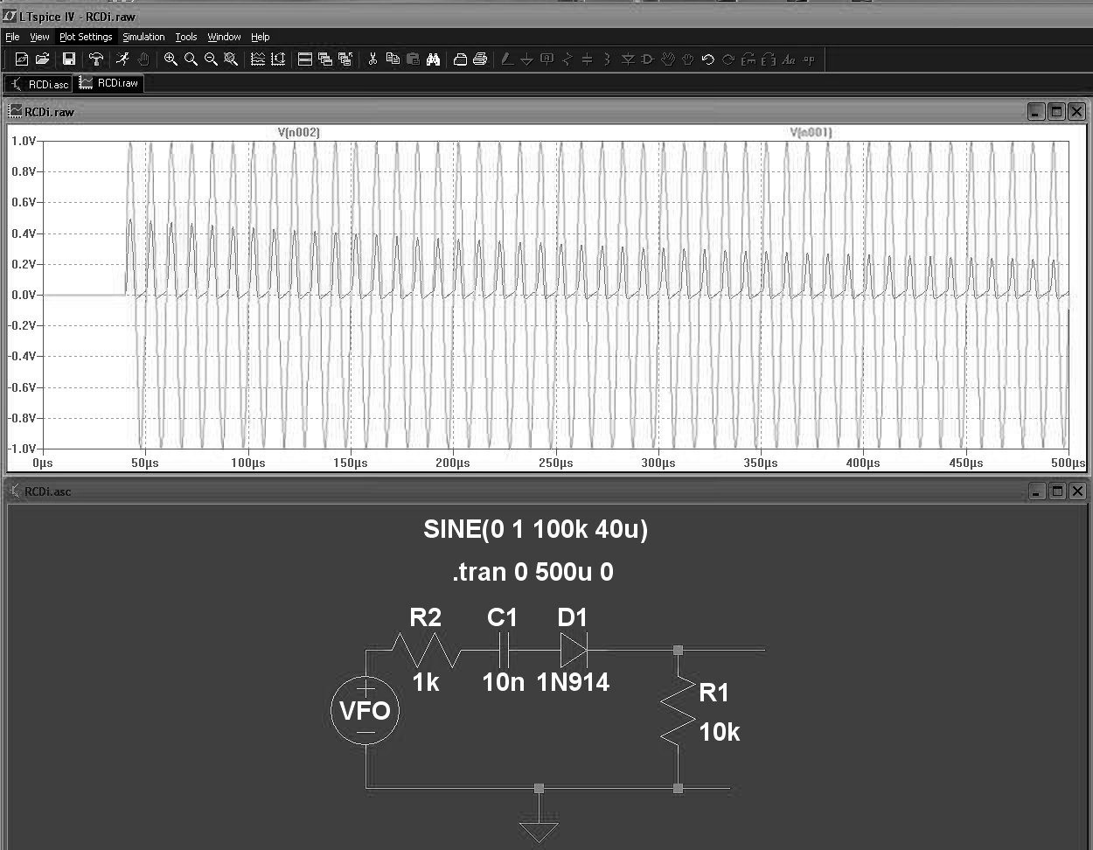

With TINA, I did a 'transient analysis, with a 0.9V rms sine wave applied at 500 Hz to a diode followed by a 10 uF capacitor, then a 100 k ohm load. ( INCIDENTALLY, although labelled as RMS it appears to produce the voltage as PEAK values...) but, allowing for the different time-constant got exactly the same kind of result.
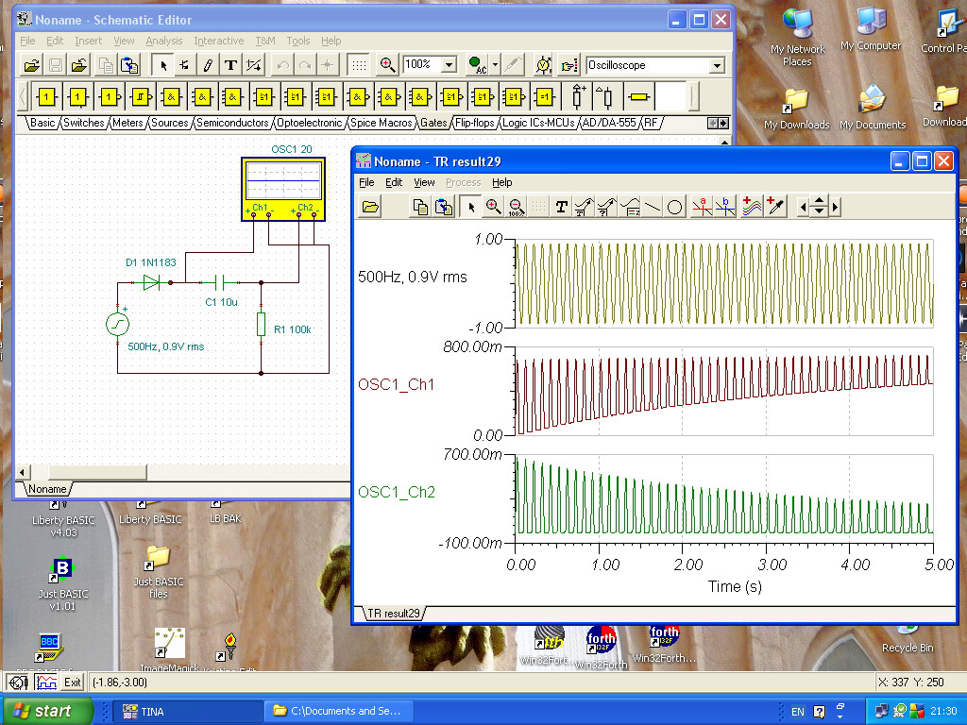
So how can a circuit like this one work? Partly because diodes are NOT perfect. But circuit modelling software usually includes parallel capacitance, series resistance and stored charge effects for diodes, modelling them with formulas like which matches real-world measurements like
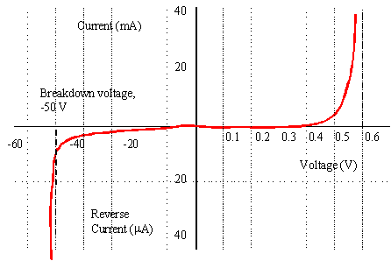

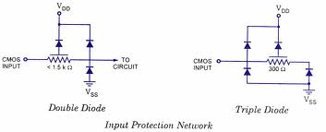
It seems the answer lies partly in the usually-invisible detail, like the input and output characteristics the amplifier which follows the 'detector', or of C-MOS circuits, whose outputs have a fairly linear resistance, usually in the region of hundreds of ohms, and whose inputs have carefully crafted shunt diode circuits to try to stop minute stray charges building to enough voltage to puncture the gate oxide and destroy the device whose gate impedance when made will typically be of the order of 1 T ohm. Typically a minimum of two reverse diodes to each power rail, and a series resistor.
In a feedback /regenerative circuit, there will also be unpredictable couplings via stray capacitance. The real series capacitor and the diodes self-capacitance form an ac voltage divider, so SOME ripple WILL get through. And there may be modulation effects due to power supply loading. Whether you can simulate ALL of these is another question. I would certainly like to see the results of testing the circuit with a decent recording oscilloscope and good hi-Z probes...
In their time most UK magazines, and Popular Electronics, a very popular American magazine, have published series diode-capacitor circuits. Popular Electronics once published a circuit involving a series chain of resistor, diode, capacitor and four-layer diode in the signal path. It could never have worked, yet I never saw this configuration challenged in US or British magazines. All are variations on the 'simple radio', where a long-wire feeds an LC tuned circuit, and a capacitor passes the rf to a diode detector or transistor base/emitter junction. Its described action is generally very badly described, and the circuit still pops up in books and on the web. I suspect some of your older readers remember 'Scroggie' and 'Cathode Ray's articles in Wireless World. He'd certainly have hated the careless design and description.
Finally, can I interest readers in other interesting special diodes and circuits? Some have been superseded, but the principles involved are still educational. Not all have been covered in EPE.

- Diode logic and diode-transistor logic ( DTL) The first generation of semiconductor logic. I remember wiring a binary to decimal to 7-segment decoder from two diode matrices..
- Use of diodes to clamp and level-shift.
- Zener diodes. And series-connected diodes as voltage references or temperature detecters.
- Use in analogue gates, using a square wave dc bias to two diodes to allow them to be passed in turn?
- Photo- diodes, used as voltage generators or as linear detectors of light. Their opposite numbers, the light-emitting LEDs and laser diodes?
- Tunnel diodes- my first introduction to the brilliant concept of a two-terminal negative resistor. ( Put it across a LC circuit, and it can exceed the power losses and make it burst into oscillation.)
- The varactor ( varicap)diode- using its voltage-controlled junction capacitance for VFOs.
- Or the Gunn microwave diode- heart of radar speed detectors?
- The low turn-on Schottky diodes.
- 'Constant current' diodes.
- Peltier diodes.
- Or the snap diode- an early way to generate very high frequency harmonics of a driver waveform?
- Or the four-layer diode, which was the foundation of transistor co-inventor William Shockley's business, and led to the breakaway founding of the likes of Intel?

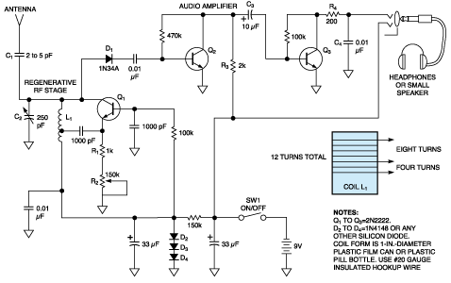
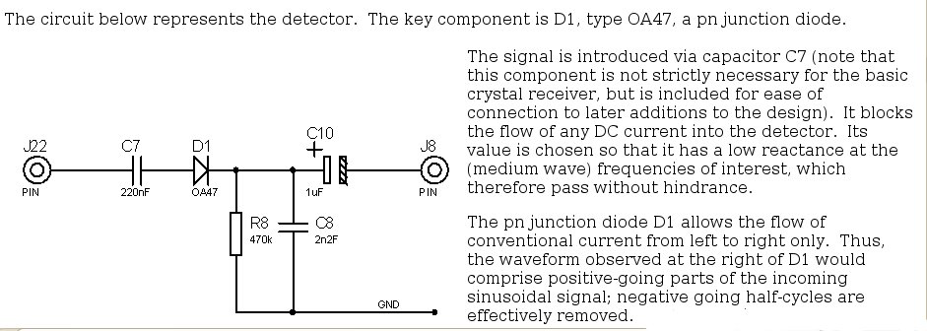
http://www2.eng.cam.ac.uk/~dmh/ptialcd/trf/trf.htm -and they went to the trouble to simulate all the developments of a radio receiver EXCEPT this first one!

